**Simple Storage Service**

Amazon S3 is an object storage which is built for storing and retrieving any amount of data at anytime,from anywhere over the internet.



Amazon resource name (ARN)

11—9 Durability

4—9 Availability

When files are uploaded to the bucket the user will specify the type of the storage class.

Later user can define features to the bucket like bucket policy,life cycle policy ,Versioning etc.

Advantages

1. **Durable** :  Probability that the object will remain intact and accessible after a period of one year
2. **Scalable**: The storage is scalable in size
3. **Low cost**: All the storage options are low cost
4. **Availability** : S3 is regional service ,we can enable CRR , so the data will be available
5. **Security**: multiple security option available at both either at bucket and object level Ex :: We can put Bucket policy ,encryption ,MFA on the data**.**
6. **Flexible**: We can chose any region ,storage classes
7. **Simple data transfer** :: Data trnafer is simple.

**Topics**

* [Buckets](https://docs.aws.amazon.com/AmazonS3/latest/dev/Introduction.html#BasicsBucket)
* [Objects](https://docs.aws.amazon.com/AmazonS3/latest/dev/Introduction.html#BasicsObjects)
* [Keys](https://docs.aws.amazon.com/AmazonS3/latest/dev/Introduction.html#BasicsKeys)
* [Regions](https://docs.aws.amazon.com/AmazonS3/latest/dev/Introduction.html#Regions)
* [Amazon S3 Data Consistency Model](https://docs.aws.amazon.com/AmazonS3/latest/dev/Introduction.html#ConsistencyModel)

### Buckets

A bucket is a container for objects stored in Amazon S3. For example, if the object named photos/puppy.jpg is stored in the johnsmith bucket, then it is addressable using the URL <http://johnsmith.s3.amazonaws.com/photos/puppy.jpg>.

**Note** :: We can copy folder to S3

**Creating bucket:**

1.Give bucket name,region and click next.

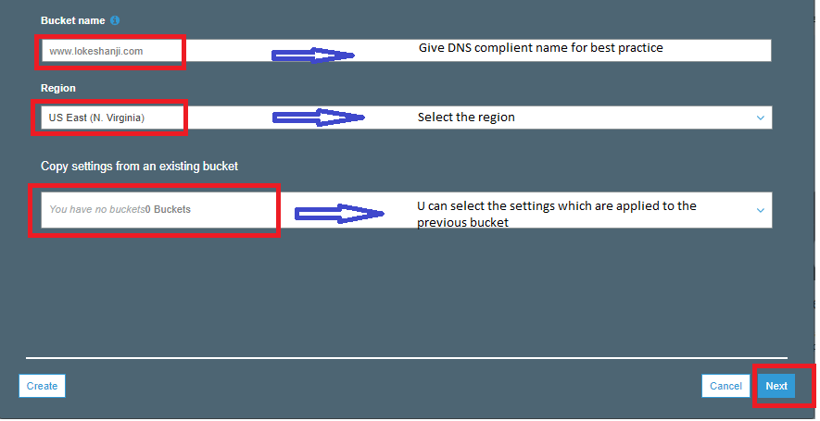

2.

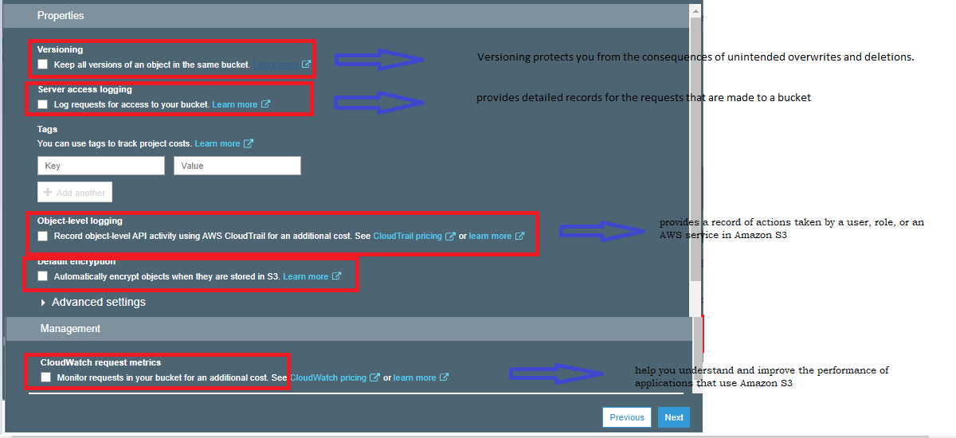

## Object Lock:

Store objects using a write-once-read-many (WORM) model to help you prevent objects from being deleted or overwritten for a fixed amount of time or indefinitely

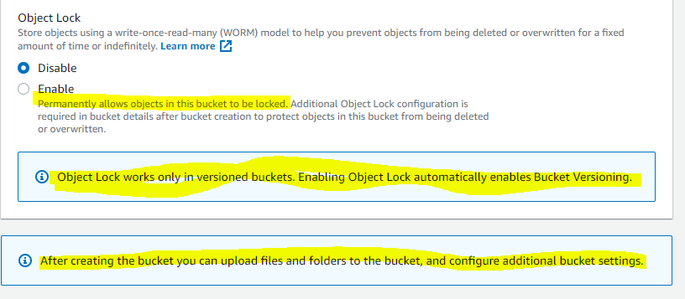

**Important**

Once you version-enable a bucket, it can never return to an un-versioned state. You can, however, suspend versioning on that bucket.

The versioning state applies to all (never some) of the objects in that bucket. The first time you enable a bucket for versioning, objects in it are thereafter always versioned and given a unique version ID.

Note the following:

* Objects stored in your bucket before you set the versioning state have a version ID of null. When you enable versioning, existing objects in your bucket do not change. What changes is how Amazon S3 handles the objects in future requests.

**3. Blocking\providing public access**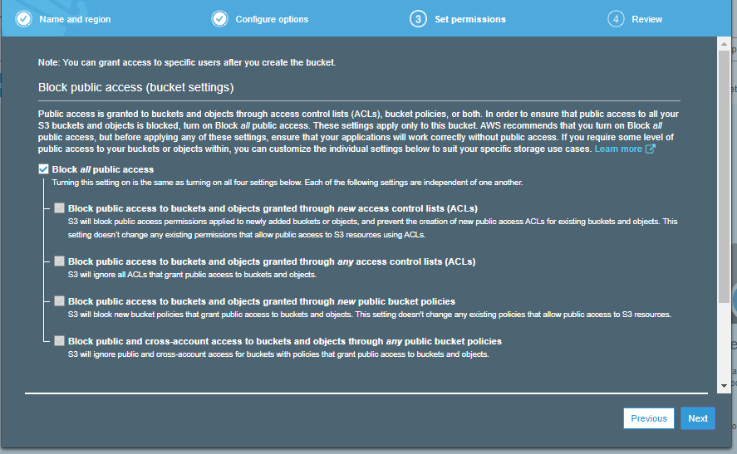

**4.Summary**

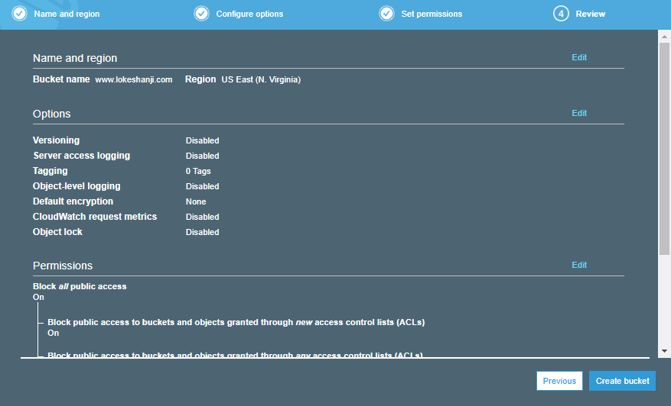

Uploading objects::

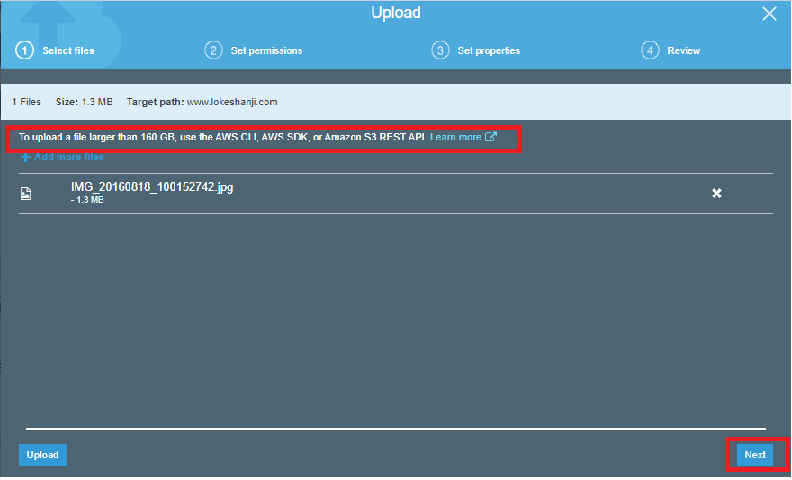

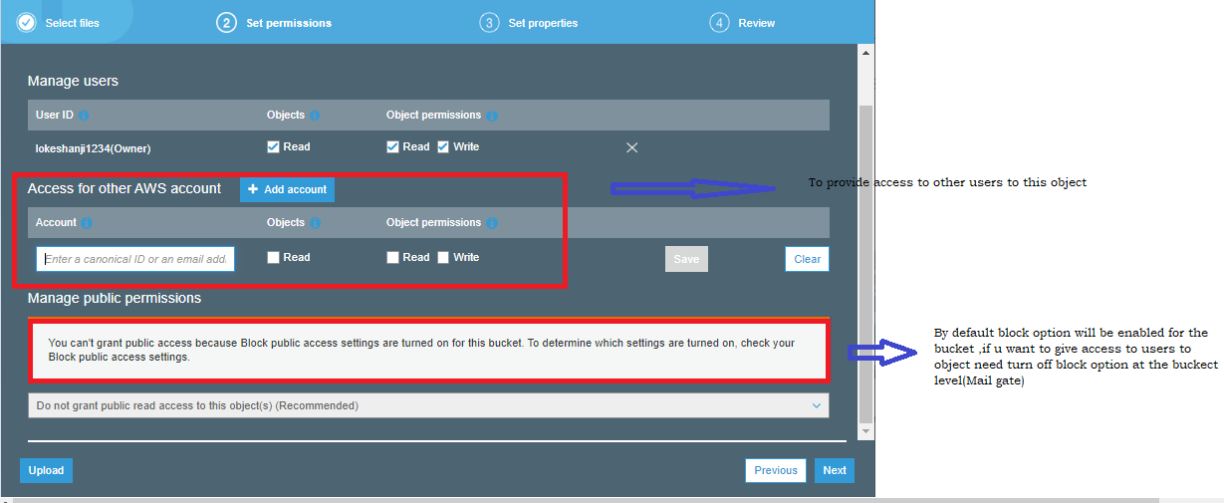

**Storage classes::**

1. **Standard** : Its default ,suitable for the use case where the latency should be less.
2. **Standard IA** :: Can be used where the data is long lived and less frequently accessed.
3. **Glacier ::** Can be used where data has to be archived and high performance is not required.
4. **One Zone-IA** : Can be used where the data Is infrequently accessed and stored in single region.
5. **Reduced redundancy storage:** Suitable for the use case where the data is not critical.

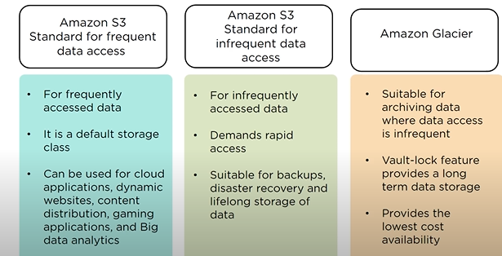

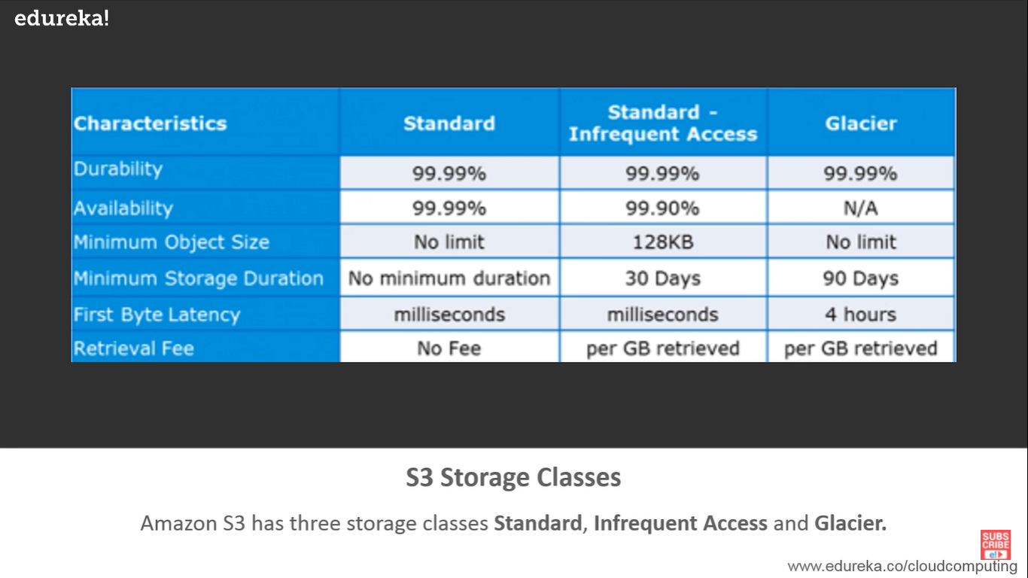

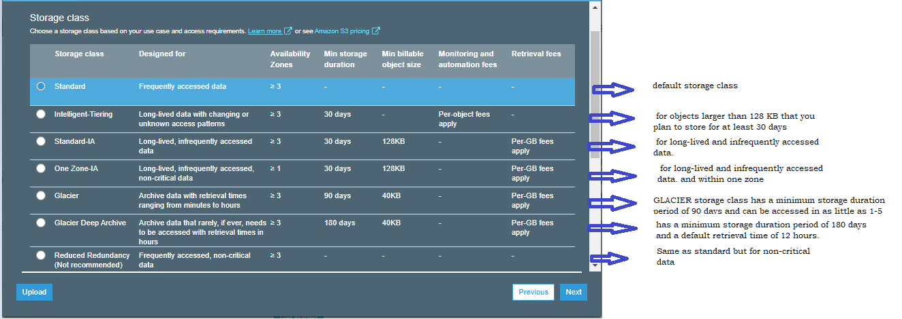

Amazon S3 Intelligent-Tiering (S3 Intelligent-Tiering)::

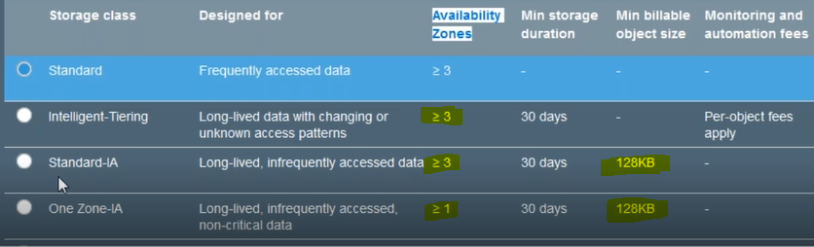

**Note** :: We can give access to other account at object level

**Cross region replication :: (CRR) : It enables automatic replication of objects ,uploaded on the bucket onto the diff AWS region**

* *Async type(response is much faster)
* We can choose diff storage class on the destination bucket
* If we delete objects/data in source bucket ,data will be available at destination bucket.

Note :: We should enable versioning for CRR. And the IAM rule too

**Transfer acceleration** :: Use-case --- (Media)

1. It enables fast,secure and easy transfers of file over long distance .
2. It uses Cloud front feature (It’s a content delivery network(CNN) service that transfers data to your preferred destination with high transfer speed)

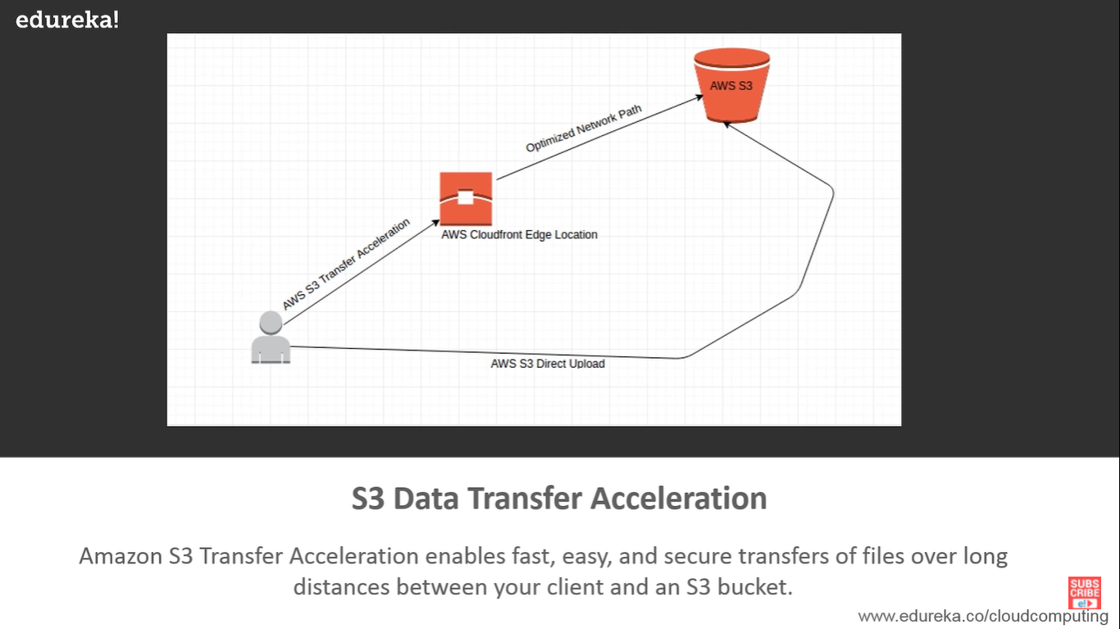

**Access control lists (ACL**): Are used to grant basic read/write permissions to other AWS account.

Note :: Using ACL giving granular control is not possible means (Giving access to only particular IP addresses)

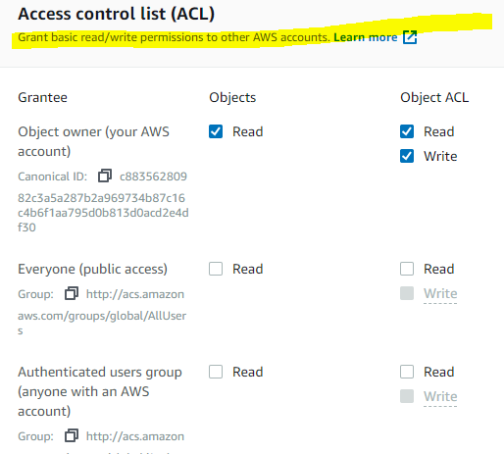



**Diff b/w ACL’s and Bucket policy:**

**Bucket Policy ::**

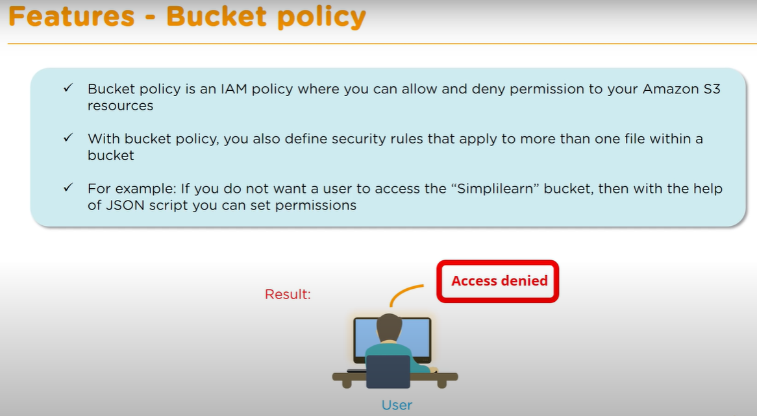

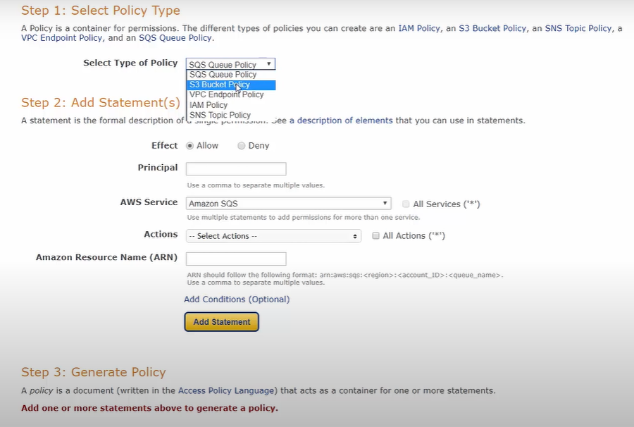

## Granting Read-Only Permission to an Anonymous User

{

"Version":"2012-10-17",

"Statement":[

{

"Sid":"PublicRead",

"Effect":"Allow",

"Principal": "*",

"Action":["s3:GetObject","s3:GetObjectVersion"],

"Resource":["arn:aws:s3:::*DOC-EXAMPLE-BUCKET*/*"]

}

]

}

**Properties of S3**

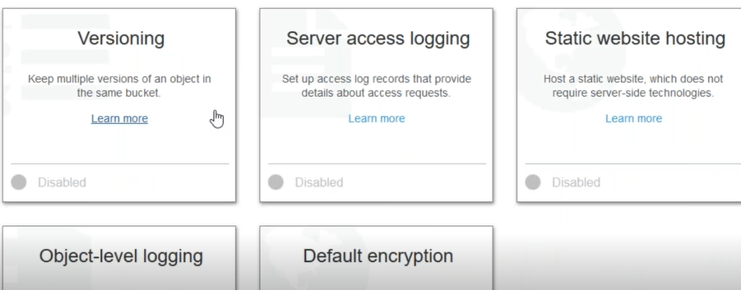

1. **Versioning** ::Use versioning to keep multiple versions of an object in one bucket .Versioning protects you from the consequences of unintended overwrites and deletions. You can also use versioning to archive objects so you have access to previous versions.

Buckets can be in one of three states: unversioned (the default), versioning-enabled, or versioning-suspended.

**Note** :: We can apply bucket policy to versioning ,so that no one can delete.

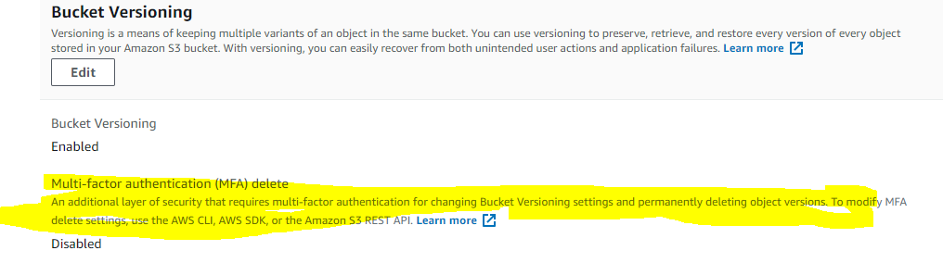

1. **Server access logging:** (“Who is making what type of access to which objects?”)

Server access logging provides detailed records for the requests that are made to a bucket. Server access logs are useful for many applications. For example, access log information can be useful in security and access audits. It can also help you learn about your customer base and understand your Amazon S3 bill.

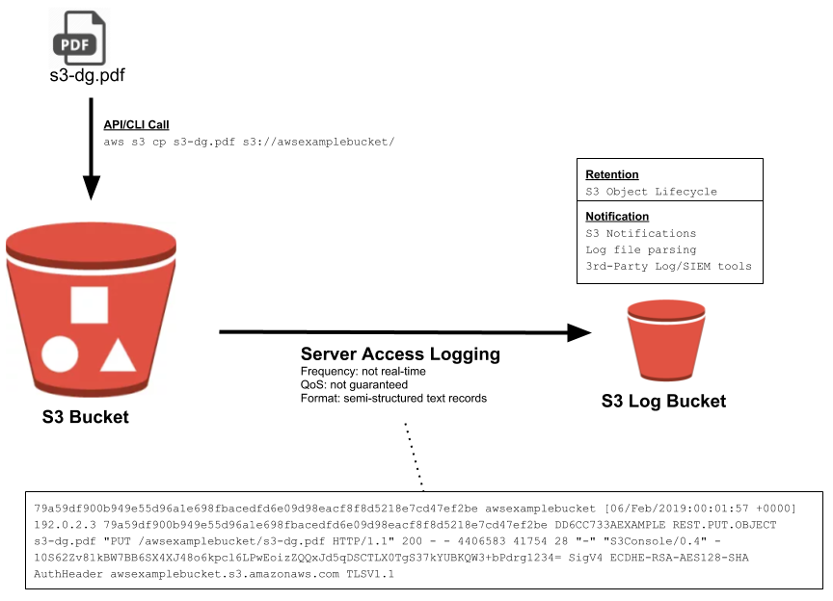

## Object-Level Logging (CloudTrail)

Object-Level Logging, sometimes referred to as S3 CloudTrail logging, saves events in json format in CloudTrail, which is AWS’s API-call eventing service. Once in CloudTrail, detailed events are stored in an S3 Bucket, and can be easily integrated with other services such as CloudWatch (monitoring/alerts), SNS (notifications), SQS (queues for other processing), and lambda functions (serverless processing).

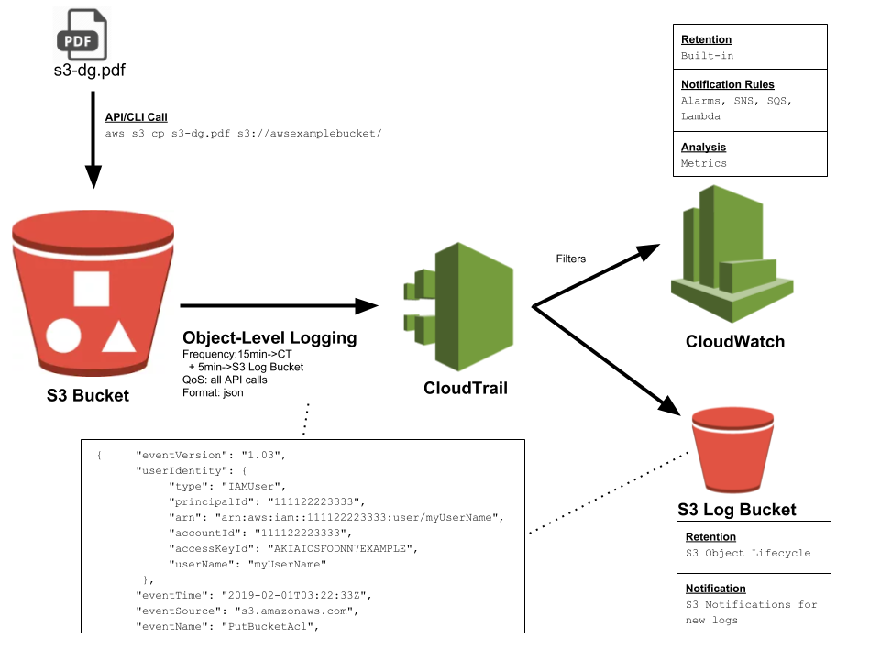

1. **Static website hosting:** Each bucket will work as a static website
2. **Encryption** :

**1)server side 2)Client side**

**Server-Side Encryption** – Request Amazon S3 to encrypt your object before saving it on disks in its data centers and then decrypt it when you download the objects.

**Client-Side Encryption** – Encrypt data client-side and upload the encrypted data to Amazon S3.

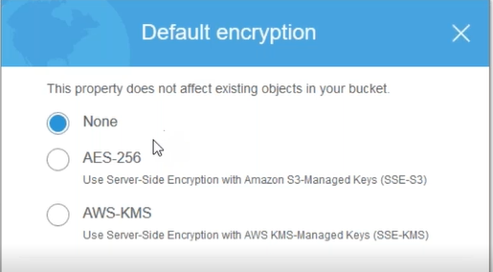

1. **Events:** will get a notification for every action over the mail

